**ROBOTIC PROCESS AUTOMATION**

**CA2 PROJECT: - Text Based Captcha**

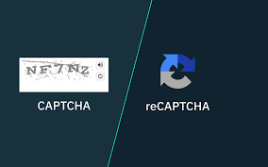

**NAME: SHARON PHILIP**

**CLASS**: **MSc-IT \ PART-2**

**ROLL NO**:  **6961**

**ABSTRACT**

CAPTCHAs (Completely Automated Public Turing test to tell Computers and Humans Apart) are well-known safety process on the internet that prevents present programs from harmful online services. It’s functioning like asking humans to complete a task that computers cannot perform, such as entering in the provided box with jumbled string bits, where the string is also considered for case sensitivity. reCAPTCHA is being used as the security parameter for the websites oppose of automatic damage through giving random auto-created conflict for users to resolve. Provided provocation are made in form that is tough for computers to resolve yet however much easier for human being. Various techniques have evolved in the past for the successful implementation of the captcha code which is not recognizable by system but are not fit as per the ML/NLP based techniques to crack the same. In the present scenario the major challenge is to provide the captcha in a way that it goes with time and the users are able to make quick response for the same. In the paper an automatic reCAPTCHA generator is being implemented which uses the embedded part of the images and text, reCAPTCHA puzzles are on the basis of the same. The embedded images are the combination of the objects and text embedded over an image. The proposed system out performed to the literature techniques in terms of success rate of 97%, precision 95% and recall 93%.

**INTRODUCTION**

For determining whether a user is a human or a computer, a CAPTCHA challenge response test is used on the World Wide Web. For differentiating Humans and Computers, the acronym which stands for Completely Automated Public Turing test is regarded. Various distorted characters, which are included in a typical CAPTCHA which is an image that is replicated at the bottom of Web registration forms. To “prove” the users to be human, they are requested to type the wavy characters. Hence, to abuse online services, CAPTCHAs act as sentries against automated programs, as we know distorted text can’t be read by the current computer programs whereas humans can. Several types of websites, like free email provider, ticket seller, social network, wikis, & blogs are protected with the help of CAPTCHAs, as for owing to their effectiveness as a security measure. Like, for purchasing a big number of concert tickets, CAPTCHAs were used as it prevents ticket scalpers from using computer programs, and this is just to re-sell them at an inflated price. With the help of some sites like: Gmail & Yahoo Mail, CAPTCHAs is used there to break spammers from getting millions of free email accounts, which they would use to send spam emails**.**

**Text Based Captcha**

Text based is considered as the most frequently used CAPTCHAs, where distorted text is replicated. The distorted characters must be identified to solve the CAPTCHA, and also correctly enter them in a designated space. Despite of the fact that Text-based CAPTCHAs are easily generate, they are susceptible to optical character recognition (OCR) attacks Carnegie Mellon University in 2000 has developed an early research-based CAPTCHA called GIMPY. 7 English words are randomly selected inside this CAPTCHA and then they have their character outlines distorted. In overlaid pairs on a colourful noisy background, the text is presented. Beside this fact that the variants exist that just use one word or string of characters, users are asked to type a certain number of these words Example of a GIMPY CAPTCHA used as an extra layer of security is shown in the figure below:

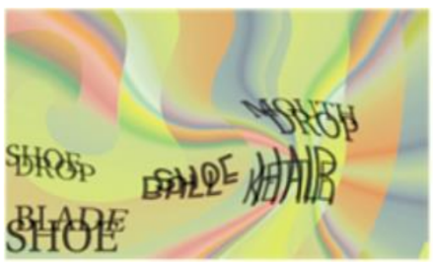

**USE - CASES**

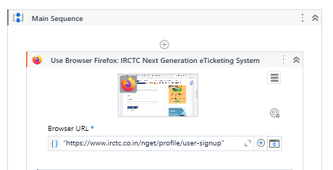

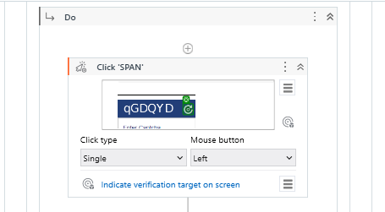

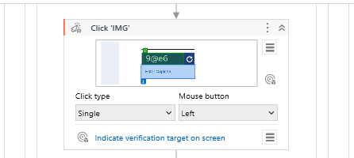

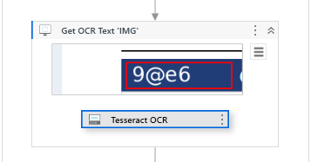

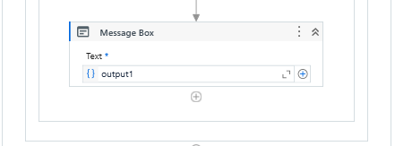

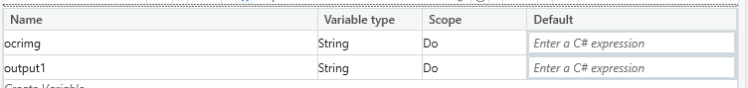

**OUTPUT**

